**SPRING MVC**

**(Hello World)**

**Get Started**

* Visit <https://start.spring.io/>
* Dependencies *“****Spring web starter****”*
* Import file to eclipse or Spring tools

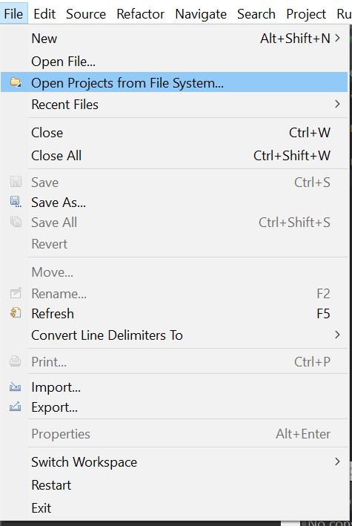

* Create new “***controller***” package

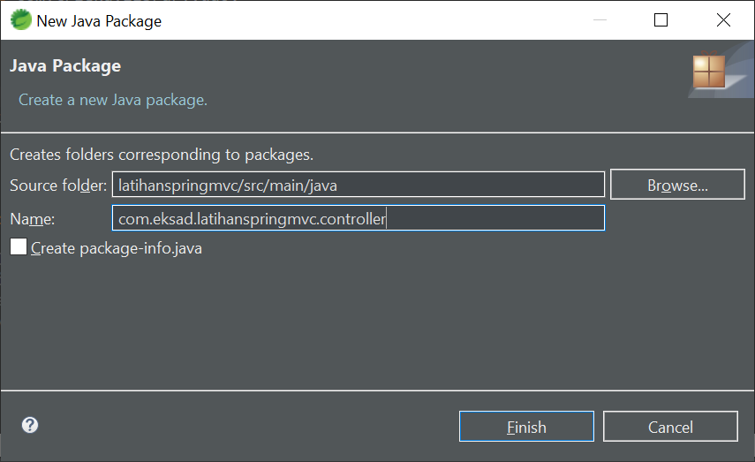

* Create new class “***controller***”
* Add annotation *@Controller*

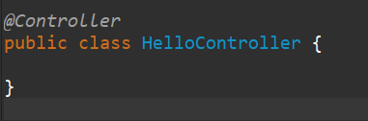

* Add annotation *@RequestMapping*("/hello")

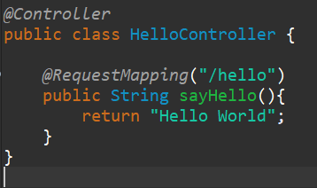

* Run main class public class LatihanspringmvcApplication { }
* Open browser <http://localhost:8080/hello>

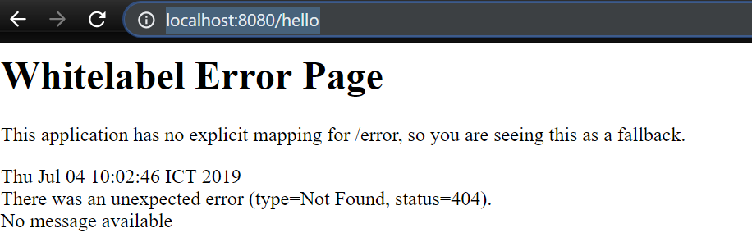

* Add annotation *@ResponseBody*

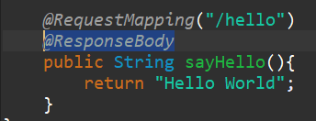

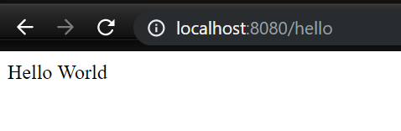

* **Using Parameter,** withadd annotation *@RequestParam*

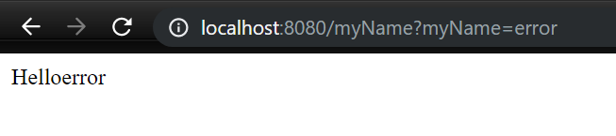

* Using variable with  *@PathVariable*

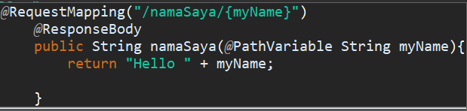

* Return Hyperlink with HTML

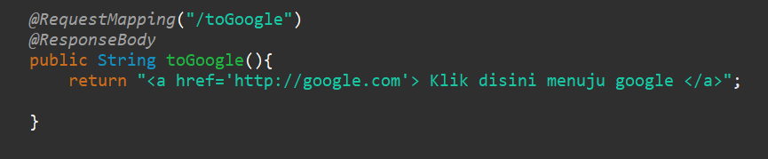

**Create HTML file**

* Open “***pom.xml***” and add new depndencies

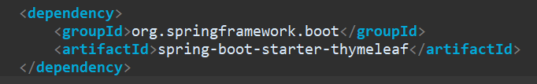

* Create new class

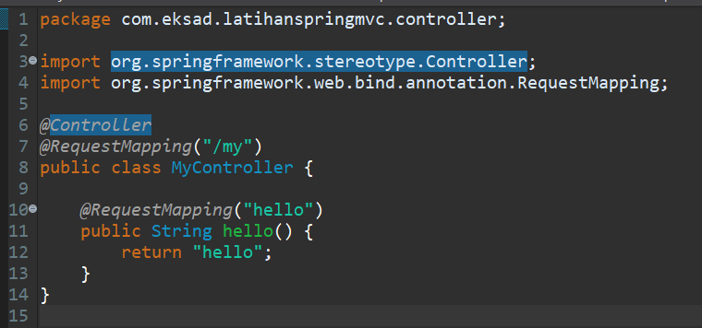

* Create new HTML file in “***src/main/resources/template”***

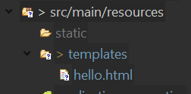

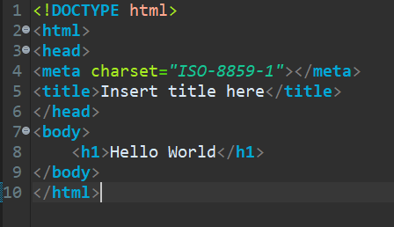

* Using parameter in HTML file

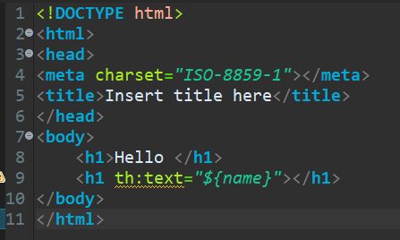

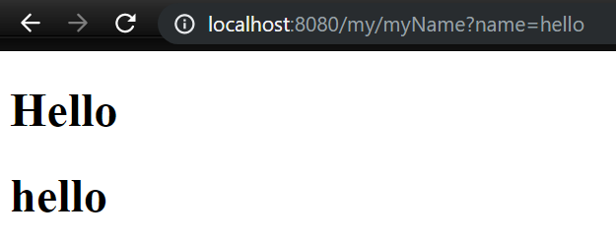

**DISPLAY DATA FROM DATABASE IN HTML**

* **Create new class and generate *Getter-Setter***

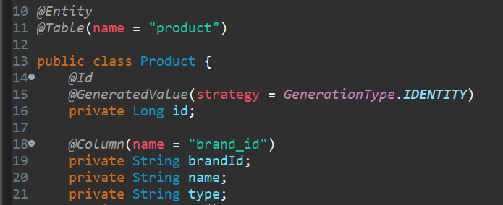

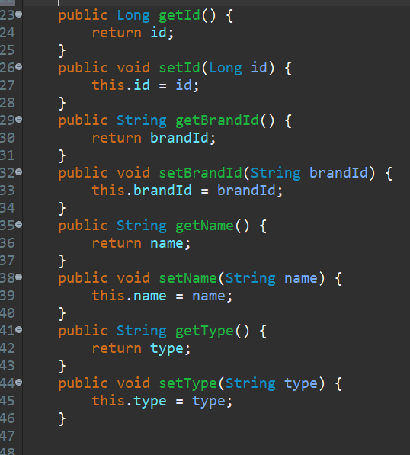

* **Add new dependencies**

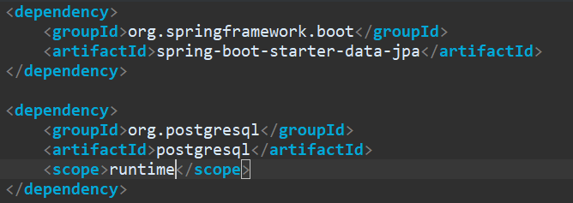

* **Create new Interface DAO** public interface ProductRepositoryDao

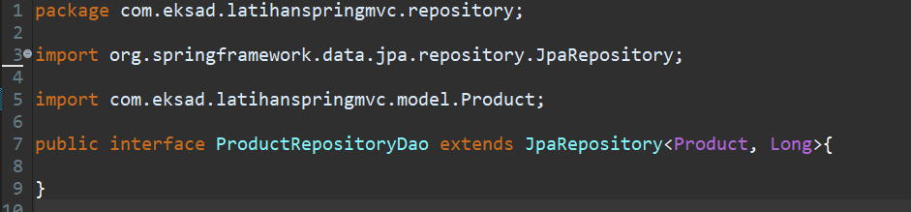

* **Create new class** public class ProductController { }

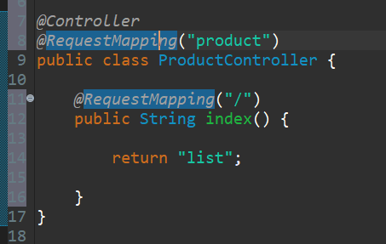

* **Define new global variable** ProductRepositoryDao

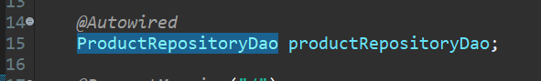

* *@RequestMapping*

